# **How to access robot using DobotStudio2020 on Windows ?**

If you have installed DobotStudio2020 on Windows, you need to follow the steps below to check whether your computer configuration file is correct. Of course, you should only use these steps as a temporary solution to regain access to the robot. Otherwise, the computer will not be able to connect and access the robot.

1. **Check your windows network environment.**

Step1: Click the Start icon (or press the WIN key on the keyboard), and then tap or click Settings.

Step2: Click Network & Internet. Turn off your Windows computer’s VPN or Pxoxy, and don’t use secure DNS.

Looked like below originally

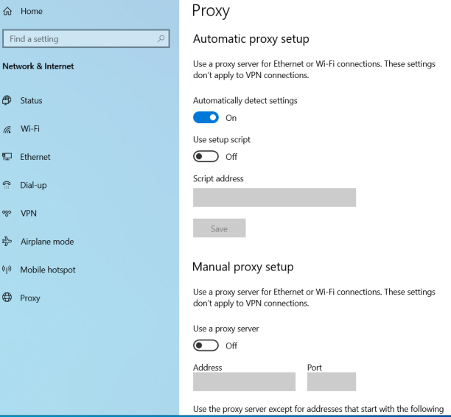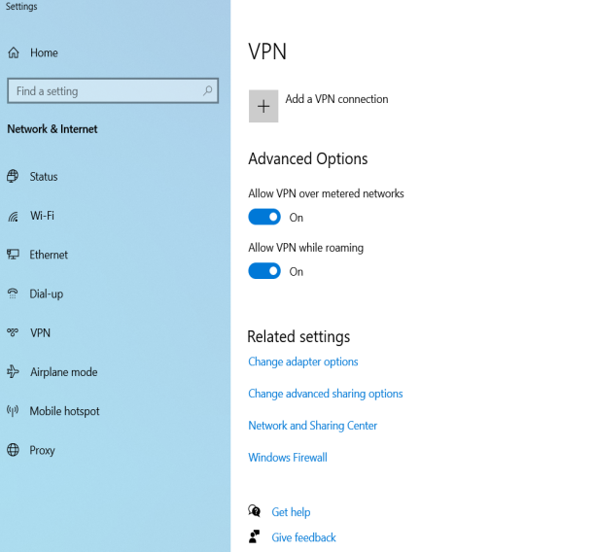

1. **setting the TCP / IP protocol in Windows**
2. Click the Start icon (or press the WIN key on the keyboard), and then tap or click Settings, Click Network & Internet.

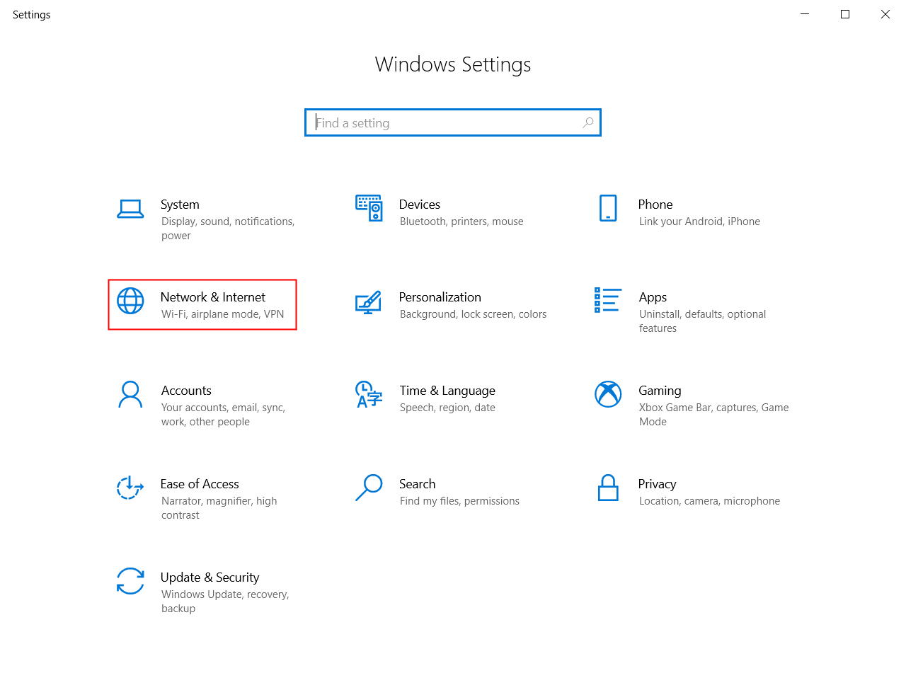

1. Click Ethernet-Click Change Adapter Options.

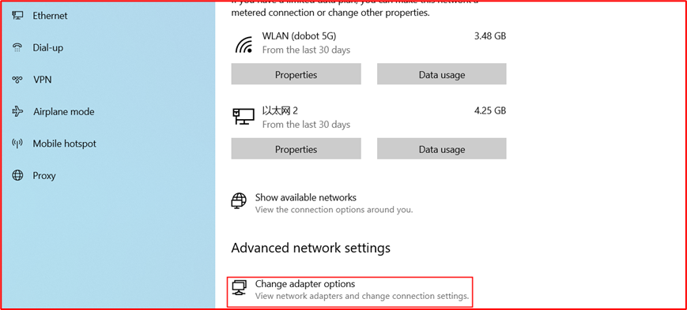

1. "Ethernet" shortcut key-> Properties

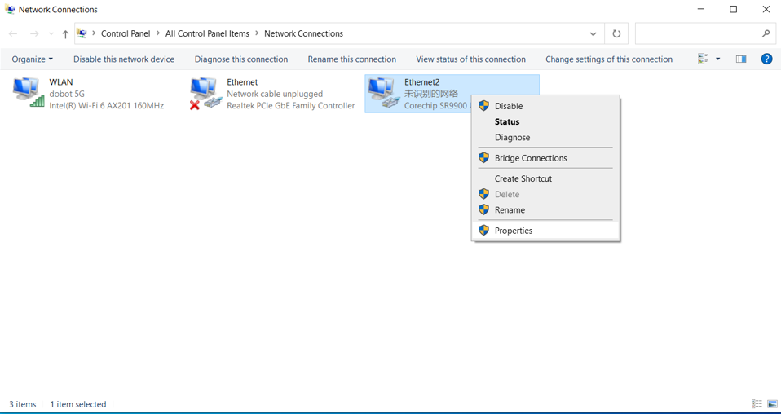

1. Select "Ethernet Communication Protocol Version 4 (TCP / IPv4)"-> Properties.
2. To click Properties to display the TCP/IP Properties dialog box; adjust the settings; and then click OK.

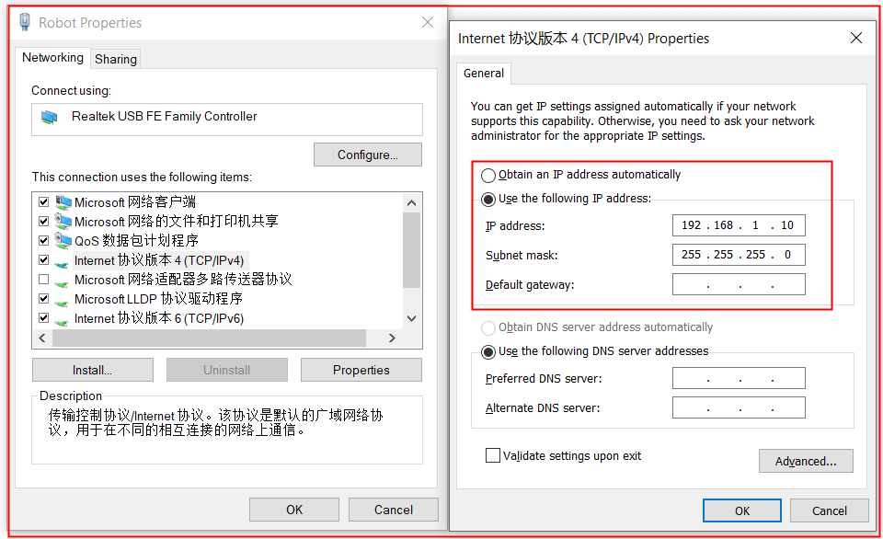

MG400 default IP is 192.168.1.6, so when your computer connect to your robot, Please select your real control IP address to 192.168.1.X , for example, 192.168.1.10.

1. **Access the "project" file**

Use the shortcut key "Windows＋R" to run the command " \\192.168.1.6 "

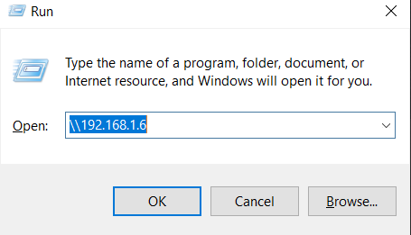

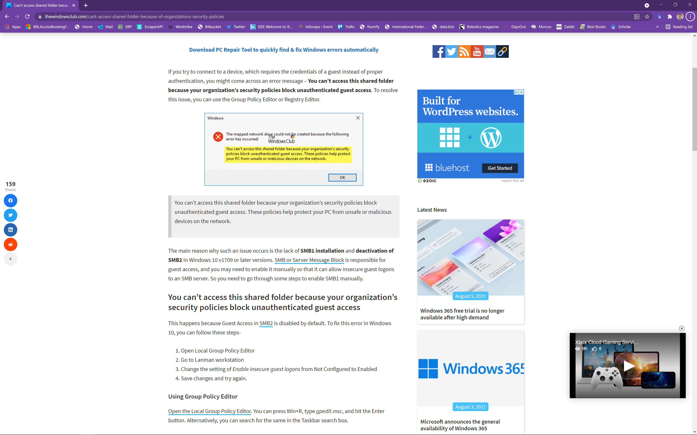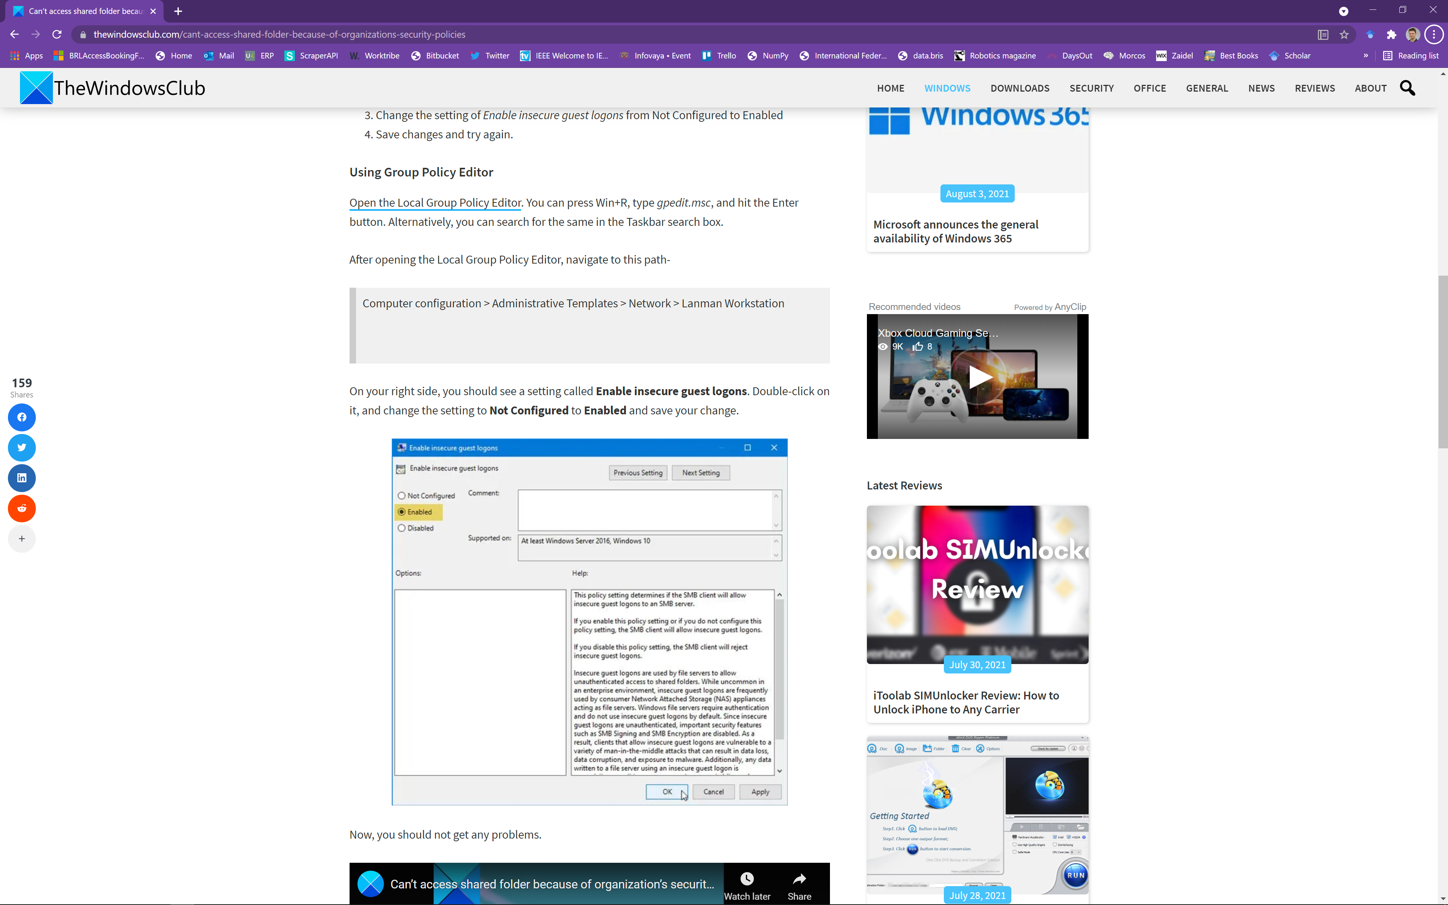

If the computer is connected to the MG400 for the first time, it needs to log in. Please enter the account root, password dobot, and check remember credentials.

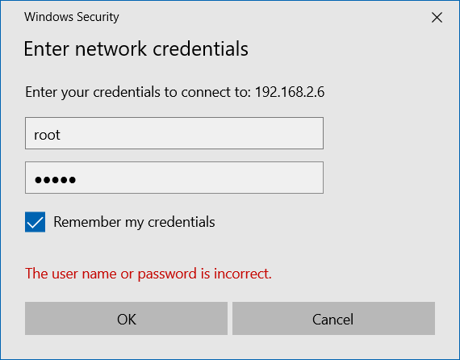

If the login is successful, you will see the following screen.

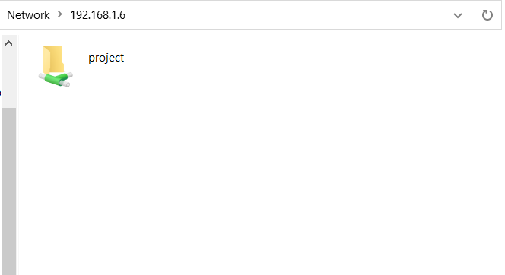

1. **Enable SMB in Windows**
2. Click the Start icon (or press the WIN key on the keyboard), and then tap or click Settings. Click the search bar, type Turn Windows feature on or off, and then press Enter key.

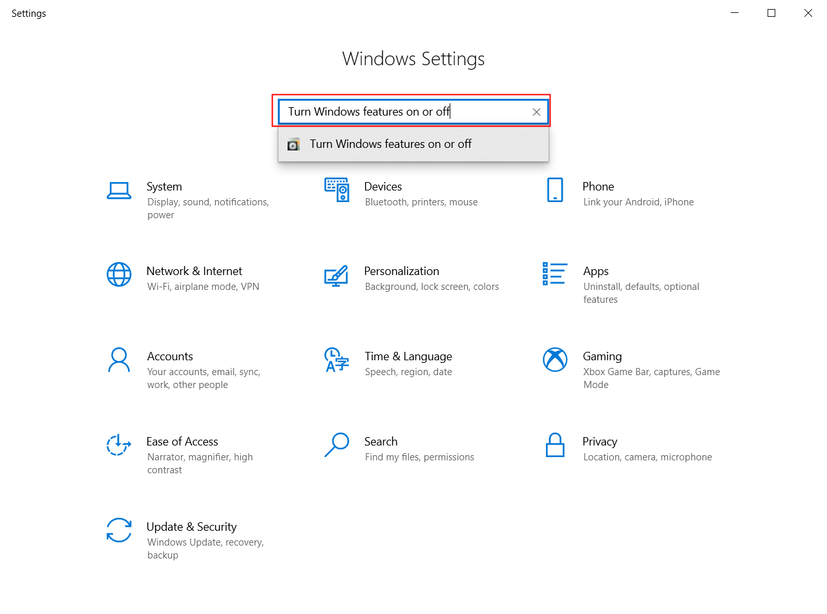

1. Scroll down and enable SMB 1.0/CIFS file sharing support, make sure to check its checkbox, expand the SMB 1.0/CIFS file sharing support option, check the SMB 1.0/CIFS client option and server option, and restart the computer .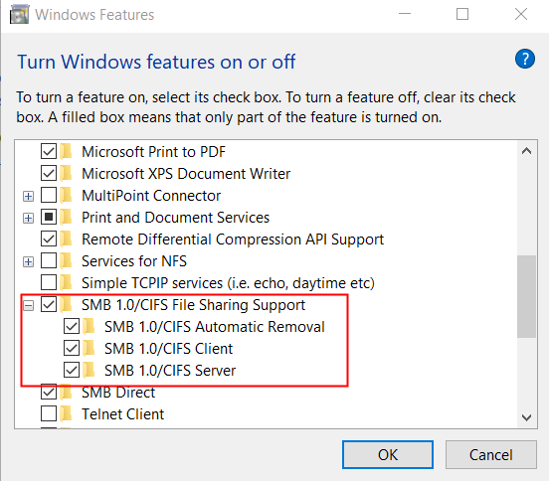
2. **Check your Windows Defender Firewall allowed apps settings.**
3. Click the Start icon (or press the WIN key on the keyboard), and then tap or click Settings. Click the search bar, type Windows Defender Firewall, and then press Enter key.

set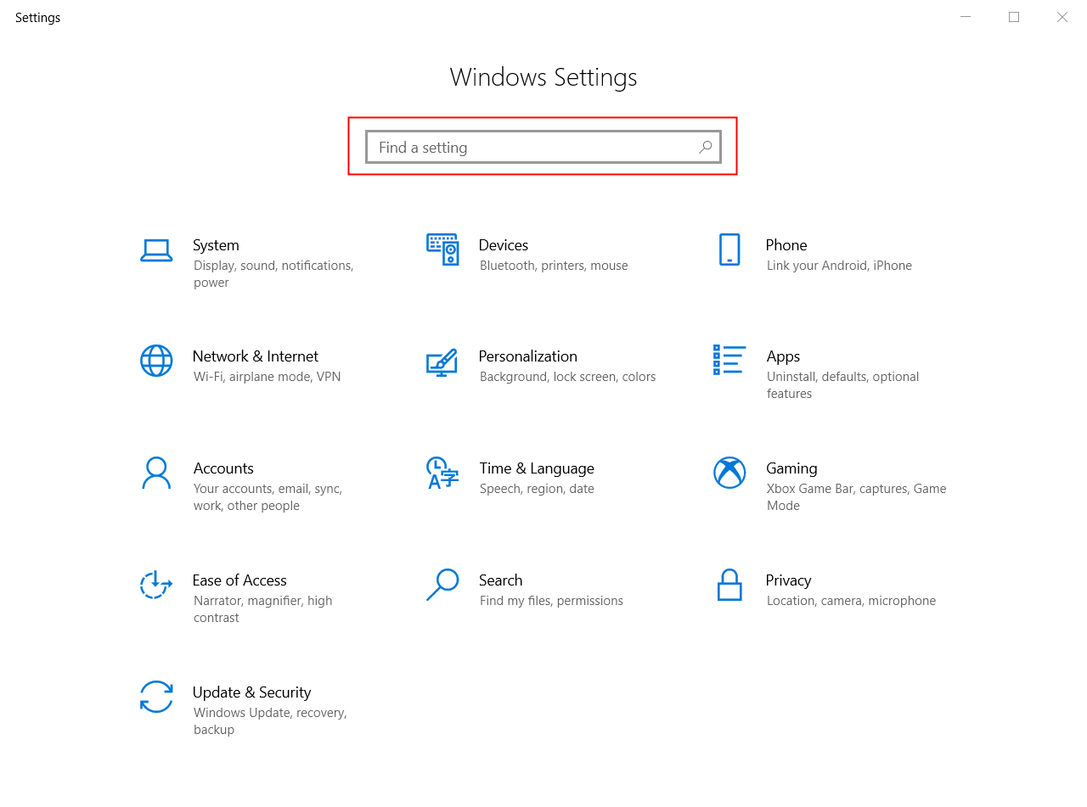

Click Allow an app or feature through Windows Defender Firewall.

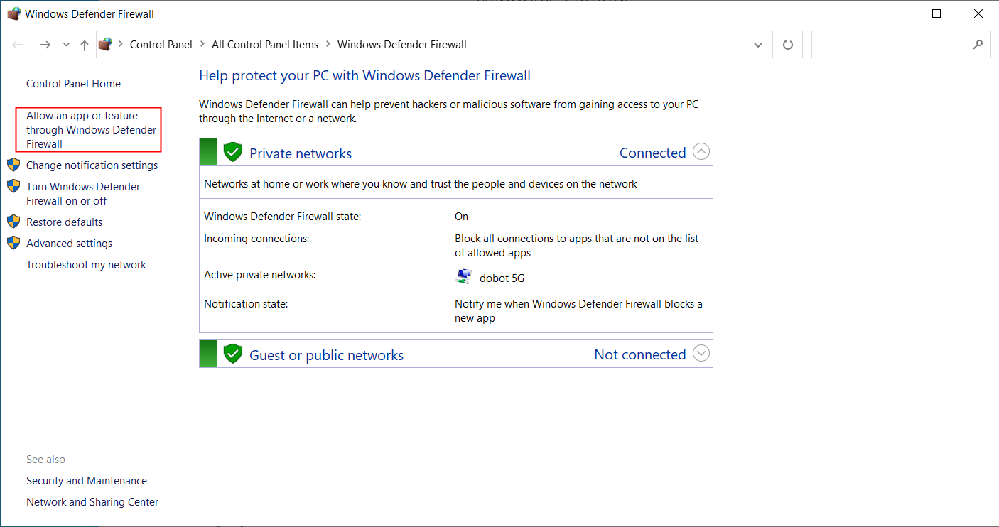

1. Select all “dobotscstudio” in the list of “Allowed apps and features”, both Private and Public are allowed. Remember to save your settings.

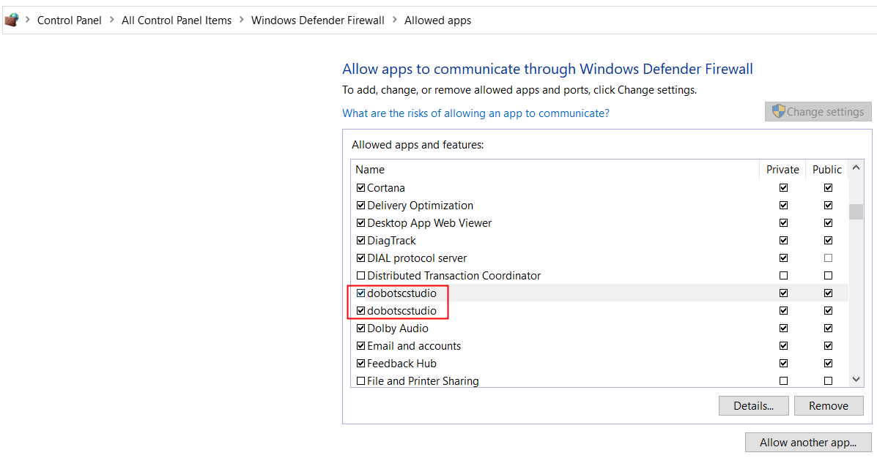

（3）If it still doesn't work, turn off the firewall.

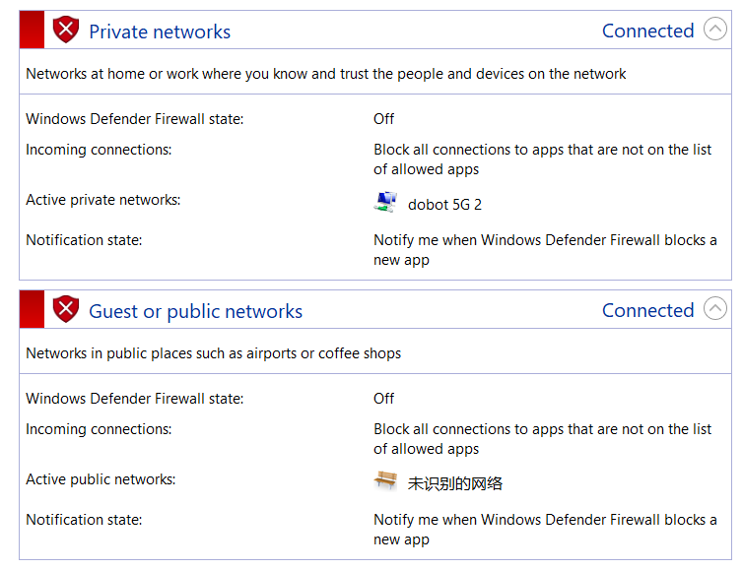

1. **Check whether the network proxy is opened**

Use the shortcut key "win+r" to run the command "inetcpl.cpl" and confirm that the proxy server is not checked.

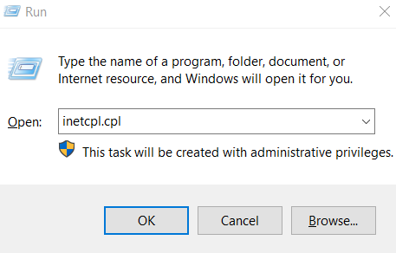

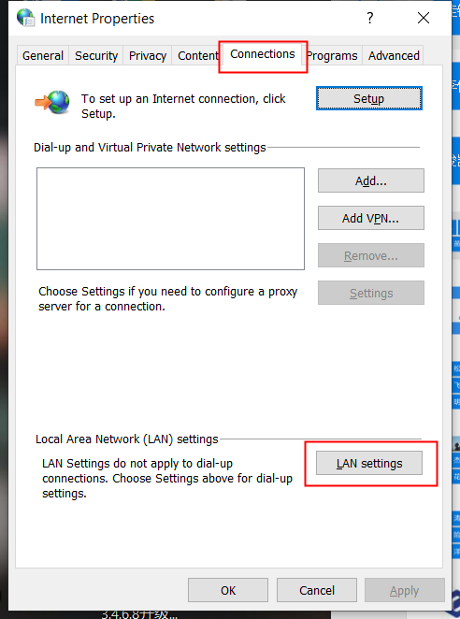

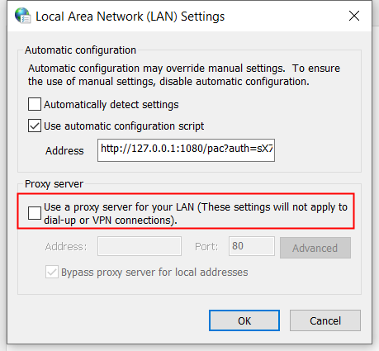

1. **Try to connect using DobotSCStudio**

Open DobotSCStudio and change the IP to "192.168.1.6".

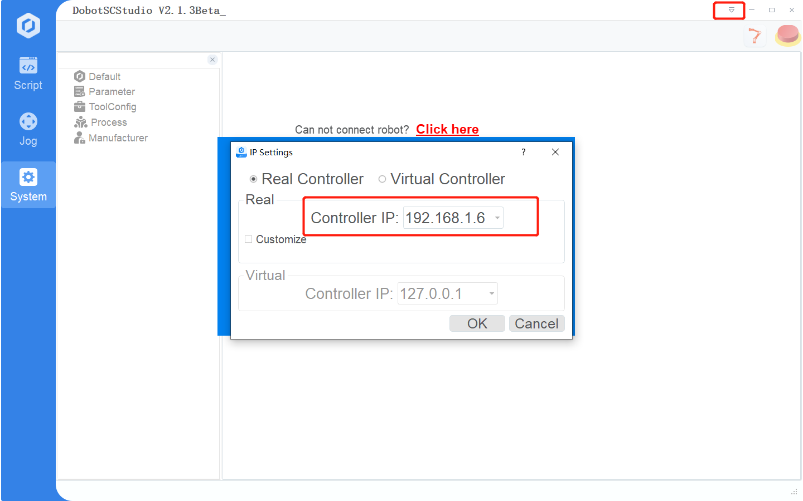

Now, here is the tutorial.

Step 1: On the target computer, press **Windows** key and **R** key together to open **Run** dialog, then type the **secpol.msc**in the box and click **OK** to continue.

Step 2: In the pop-up window, navigate to the **Local Policies** > **Security Options** in the left panel. Then select the **Network Security: LAN Manager authentication level** and double-click it.

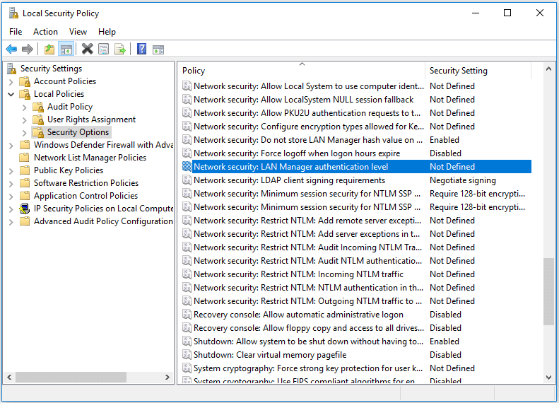

Step 3: From the drop-down menu, select **Send LM & NTLM-use NTLMv2 session security if negotiated**. Click **Apply** and **OK** to continue.

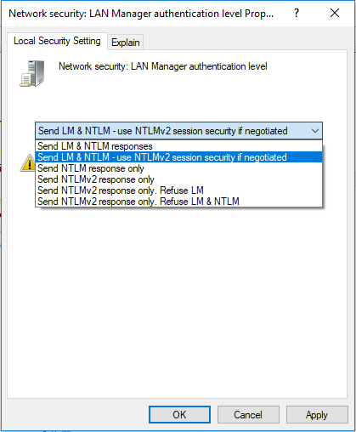

tep 1: On the target computer, press **Windows** key and **R** key together to open **Run** dialog, then type the **ncpa.cpl**in the box and click **OK** to continue.

Step 2: Right-click the network and choose **Properties**.

Step 3: Double-click on the **Internal Protocol Version 4**.

Step 4: In the pop-up window, click **Advanced…** to continue.

Step 5: In the pop-up window, go to the **WINS** tab. Then check the option **Enable NetBIOS over TCP/IP**. At last, click **OK** to continue

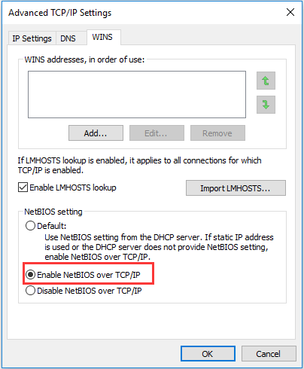

When all steps are finished, you can check whether the issue the network path not found is solved.